Reflexology Practitioner Diploma Course Syllabus
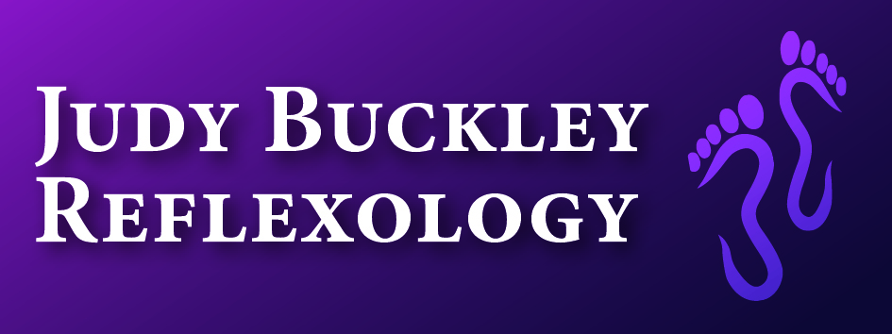

Module 1: An insight into the Principles of Reflexology
On completion of this module the learner will:
- Have a knowledge of the history, origins and philosophy of reflexology.
- Competently have a holistic approach to reflexology, for the promotion of client’s overall health and well-being.
- Have an awareness of any possible client contra-indications, cautions and aftercare advice.
- Understand any potential reactions that may occur during and after treatment.
- Be able to confidently provide reassurance during the healing process to client’s, regarding any illnesses.
- Be responsible for own personal care and well-being.
- Understand zones and the associated functions.
- Understand the requirement for case studies and research.

Module 2: Therapeutics - This module enables students to fully understand the therapy of reflexology
On completion of this module the learner will:
- Interpret and use reflexology charts for both the foot and hand.
- Identify the reflex points on the feet and hands and how they relate to the body.
- Have an understanding of observing and addressing the feet, using the correct thumb and finger walking techniques and the correct technique for holding the feet during therapy.
- Be competent in the implementation of the sequence of reflexology treatment, including an evaluation of the sense of touch relative to the client’s individual needs.
- Understand any potential reactions that may occur during and after treatment.
- Be able to appreciate the importance of monitoring treatment in case studies.

Anatomy & Physiology
Module 3: The Digestive System & Nutrition- This module will highlight the importance of nutrition, in order to maintain good health and well-being. Learners will gain an understanding of the functioning Digestive System, which will include the associated Excretory System. Consideration will also be given to aliments of the systems and relevant therapy treatment.
On completion of this module the learner will understand the following:
- The importance of daily water intake.
- The requirement for macronutrients, including carbohydrates, fats and proteins and the foods that supply the macronutrients.
- Explanation of the micronutrients.
- The importance of a healthy diet for specific health conditions including nervous systems, heart, the digestive system, diabetes, respiratory system, endocrinology, fertility, menopause etc
- The components of the Digestive System including the Mouth, Pharnyx, Oesophagus, Stomach, Small Intestine, Large Intestine, IIeo caecal valve, Liver, Gallbladder & Pancreas.
- Where to locate the reflexes for the Digestive System, through the use of foot shading charts and practical activities.

Module 4: The Endocrine System
On completion of this module the learner will:
- Understand the main hormones released by the endocrine glands into the blood stream and their function.
- Understand how reflexology therapy can benefit any hormone imbalances.
- Have a knowledge of the below areas of the endocrine system:
- The Pineal Gland
- The Hypothalamus Gland
- The Pituitary Gland
- The Thyroid Gland
- The Parathyroid Gland
- The Thymus Gland
- The Adrenal Glands
- The Pancreas
- The Ovaries
- The Testes
- Recognise common endocrine health conditions and hormone imbalances and the subsequent effect on the body.
- Be familiar on the location of the reflexes for the endocrine system, through the use of foot shading charts and practical activities.

Module 5: The Reproductive System
On completion of this module the learner will:
- Understand the reproductive system and the functions.
- Become familiar with the male and female organs, the menstrual cycle and fertility issues.
- Recognise the benefit of reflexology practice to treat common reproductive issues.
- Be familiar on where to locate the reflexes for the reproductive system, through the use of foot shading charts and practical activities.

Module 6: The Cardiovascular System - Heart and Cardiovascular System
On completion of this module the learner will understand:
- The role and function of the heart
- The composition of blood and plasma
- The purpose and functions of red and white blood cells
- The flow of blood through the heart to and from the body and lungs, including the arteries and veins.
- The benefit of reflexology treatment to assist with heart diseases and increase blood circulation.
- The location of the reflexes for the Cardiovascular System, through the use of foot shading charts and practical activities.

Module 7: The Respiratory System
On completion of this module the learner will:
- Be familiar of the both the structure and function of the Respiratory System.
- Understand the key components of the Respiratory System including the Nose, Pharynx, Larynx, Trachea, Bronchi, Diaphragm, Lungs, Alveoli and Internal and External Respiration.
- Recognise the benefit of reflexology to treat common respiratory illnesses.
- Be able to identify the reflexes for the Respiratory System, through the use of foot shading charts and practical activities.

Module 8: The Urinary System
On completion of this module the learner will:
- Be familiar with the physical structures of the main components in the urinary system and their functions.
- Have a good understanding the kidneys, nephrons, urethra, ureters, bladder and the formation of urine, in the body.
- Recognise the benefit of reflexology as a therapy to treat common issues, within the urinary system.
- Competently identify the reflexes for the urinary system, through the use of foot shading charts and practical activities.
Module 9: The Nervous System
On completion of this module the learner will:
- Understand the importance of the overall nervous system and its functions.
- Be aware of the individual components to include the Neuron, the Cerebrum, the Brain Stem, Medulla Oblongata, Reticular activating system, the Cerebellum, Cerebro (Spinal fluid), the Spinal Cord, Spinal Nerves, Cranial Nerves, Autonomic Nervous system (sympathetic & parasympathetic divisions).
- Understand the how the body reacts with stress response and related disorders.
- Recognise the benefit of how reflexology therapy assists with stress management and how to can be used as a coping mechanism.
- Be able to identify the reflexes for the Nervous System, through the use of foot shading charts and practical activities.

Module 10: The Lymphatic System & Immunity
On completion of this module the learner will:
- Have an understanding of the importance of the overall Lymphatic System and its role within the body.
- Consider the purpose of the lymph vessels/nodes, lymph tissue, the spleen, the tonsils, adenoids and the thymus gland.
- Be familiar with the benefit of reflexology in assisting with any Lymphatic disorders or irregularities.
- Recognise the reflexes for the Lymphatic System, through the use of foot shading charts and practical activities.

Module 11: Muscular & Skeletal Systems
On completion of this module the learner will:
- Be familiar with the overall purpose of the muscular and skeletal systems within the body.
- Understand the key components that are part of the muscular and skeletal systems, within the body including the bones, tissues cartilage, ligaments, tendons, muscle tissue, joints, movement, structural support and protection, the Axial skeleton, the Appendicular skeleton, the Thoracic Cage, Muscles of Respiration, the Shoulder Girdle, the Pelvic Girdle and the specific bones and muscles of the feet and hands.
- Consider the benefit of reflexology as a support to improve any underlying issues associated with the muscular and skeletal systems within the body.
- Be able to identify the reflexes for the Skeletal System, through the use of foot shading charts and practical activities.

Module 12: Integumentary System
On completion of this module the learner will understand:
- The structure and function of the skin, to assist with protection, regulation and sensation of the body.
- The benefit of reflexology for the overall integumentary system, including any issues associated with healthy hair and nails.

Module 13: Practitioner Development and Ethics - This module provides a comprehensive understanding of positive practice, the NRRI Code of Ethics and professional conduct.
On completion of this module the learner will understand:
- The procedure for referral to other healthcare professionals, therefore working as part of a multidisciplinary team.
- The importance of positive communication skills to enable them to provide a high standard quality of care, throughout the individual assessment of clients.
- What is involved in setting up their own individual practice, including advertising and marketing.
- The roles and objectives of the National Register of Reflexologists Ireland.
- The requirement for Professional Insurance and Registration with NRRI.
- The NRRI Code of Ethics and Professional Conduct.
- The initial consultation sheets and the importance of recording keeping in line with the General Data Protection Regulation (GDPR).
- Health & Safety requirements within the practice.
- First Aid certification.

Module 14: Basic First Aid
This module will provide learners with a knowledge of first aid, which will be beneficial within the practice of reflexology. The course will be carried out by fun and interactive trainers, whom will take a step-by- step approach to help you learn first aid and feel confident, within the practice. All learners will subsequently be awarded with a Certificate of Attendance in Basic First Aid.

Case Studies & Clinical Training
Learners will be assessed weekly through the use of Question and Answer sessions, at the beginning of class, to ensure information remains clear and as learners continue to practise what they have learnt, which is known to benefit overall performance.
All learners will be required to be continually assessed through case studies, throughout the duration of the course. Learners are required to complete a minimum of 60 hours of case studies, outside of class sessions. The case studies involve structured reflexology treatments on the learners’ own family and friends. However, in addition to practical reflexology treatments each case study requires learners to then follow up, by compiling written reports on treatments required, using the NRRI case study templates provided by the Registry. Case studies submitted at the end of the course will be assessed on presentation, in addition to technique, approach, professionalism and personal evaluation.
Learners will attend tutorials to assist with the completion of case studies, designed to give them the confidence and ability to offer a full reflexology treatment.
The tutorials will include:
- The initial preparation of the therapy room.
- Good health & hygiene practice.
- Knowledge to compile a client profile and assessing medical history, for first instance treatments.
- Subsequent treatments and charting of painful reflexes.
- Use of helper/cross reflexes.
- Relevant aftercare advice.
- Importance of client feedback.
- Evaluation of treatment.
- Presentation of the Case Studies.
The final assessment will include a 2.5 hour written examination comprising of the Anatomy, Physiology and Reflexology Practice. In addition, there will be a further practical assessment in the afternoon of that same day.
There will be two additional revision sessions for all learners, at a mutual agreed date, which will be confirmed in advance of the final assessments, these are included to give you the best possible learning experience and support.
An approved NRRI examiner will conduct and mark the assessment.

